LANGCHAIN CONFIG

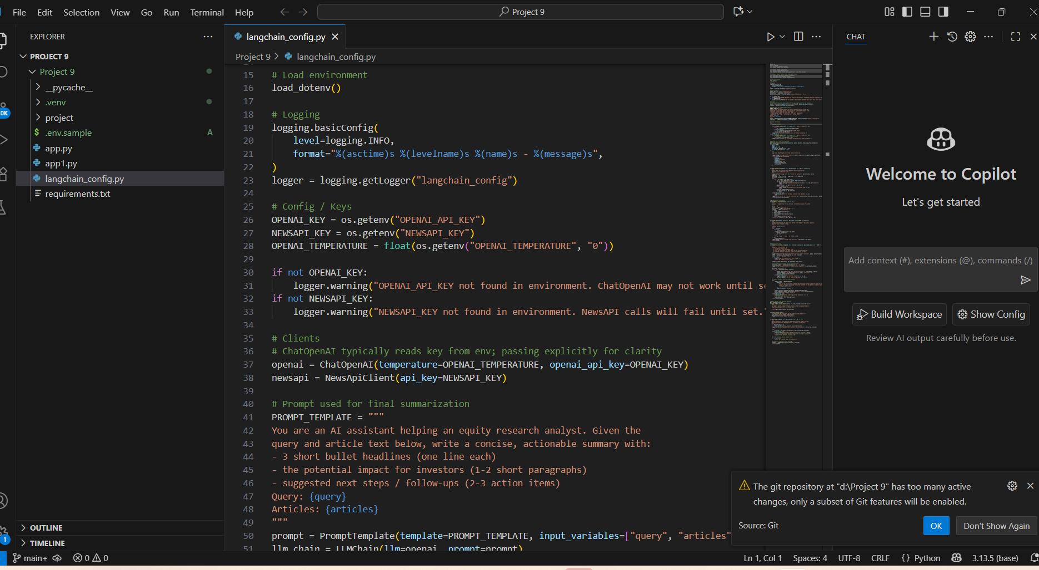

Result

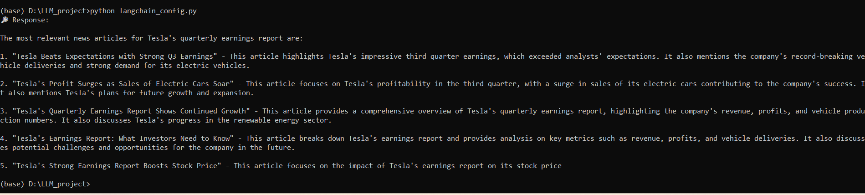

App.py for streamlit

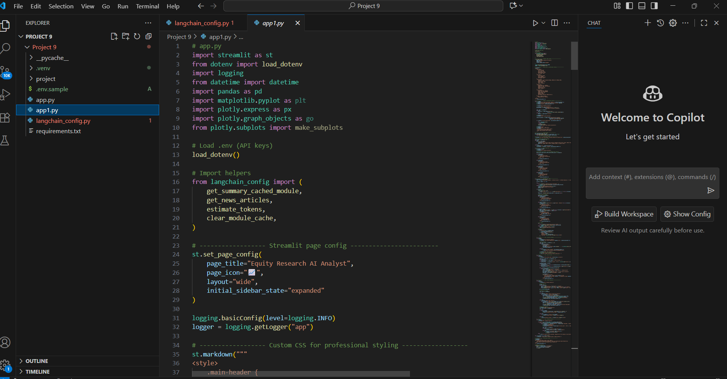

Result

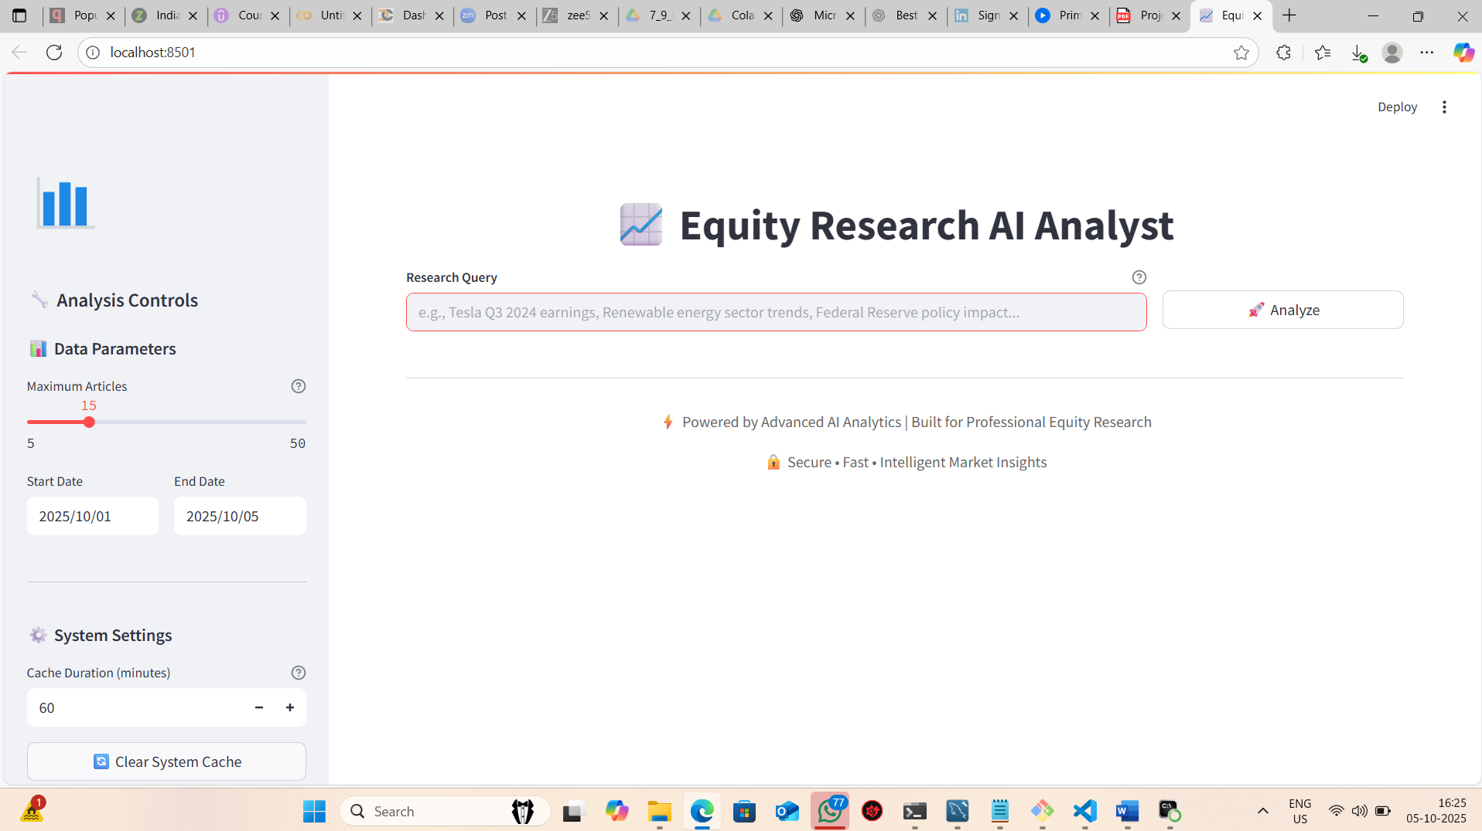

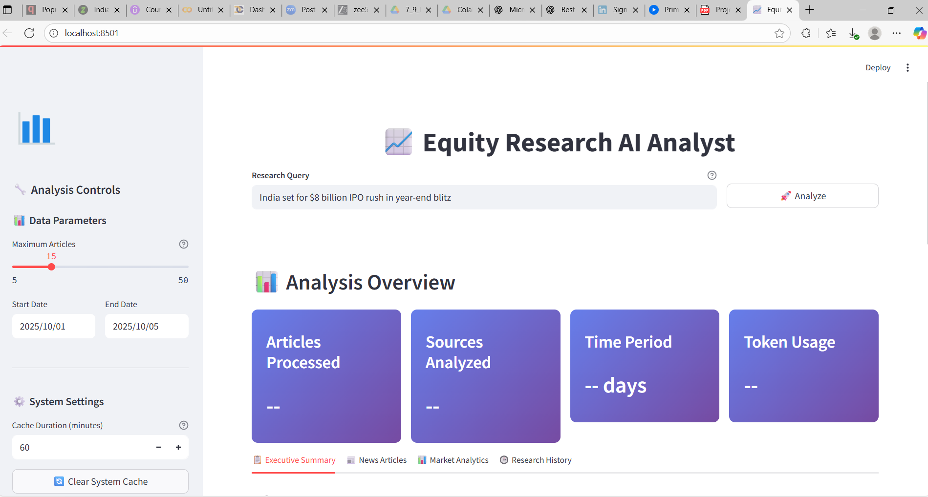

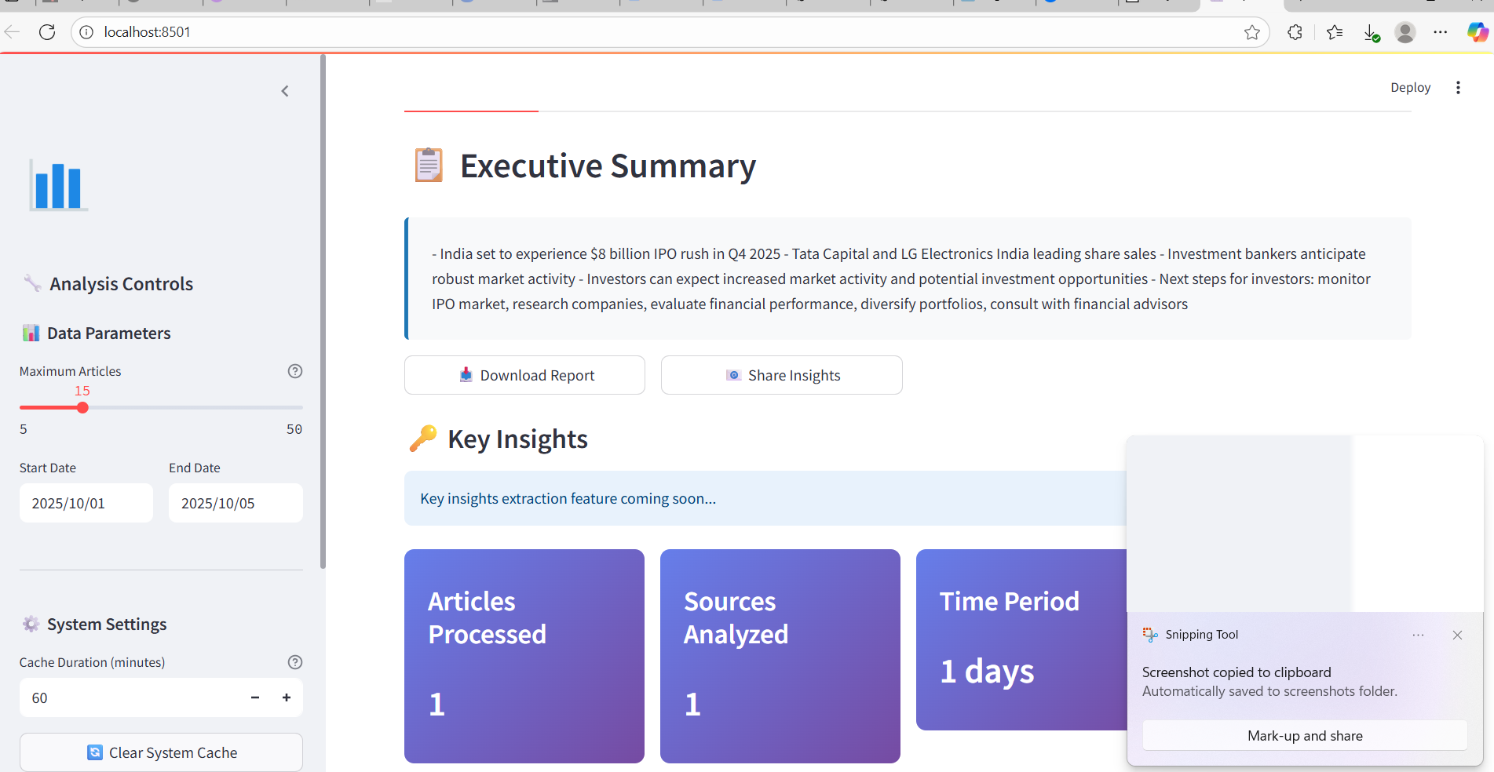

Deployment the Project

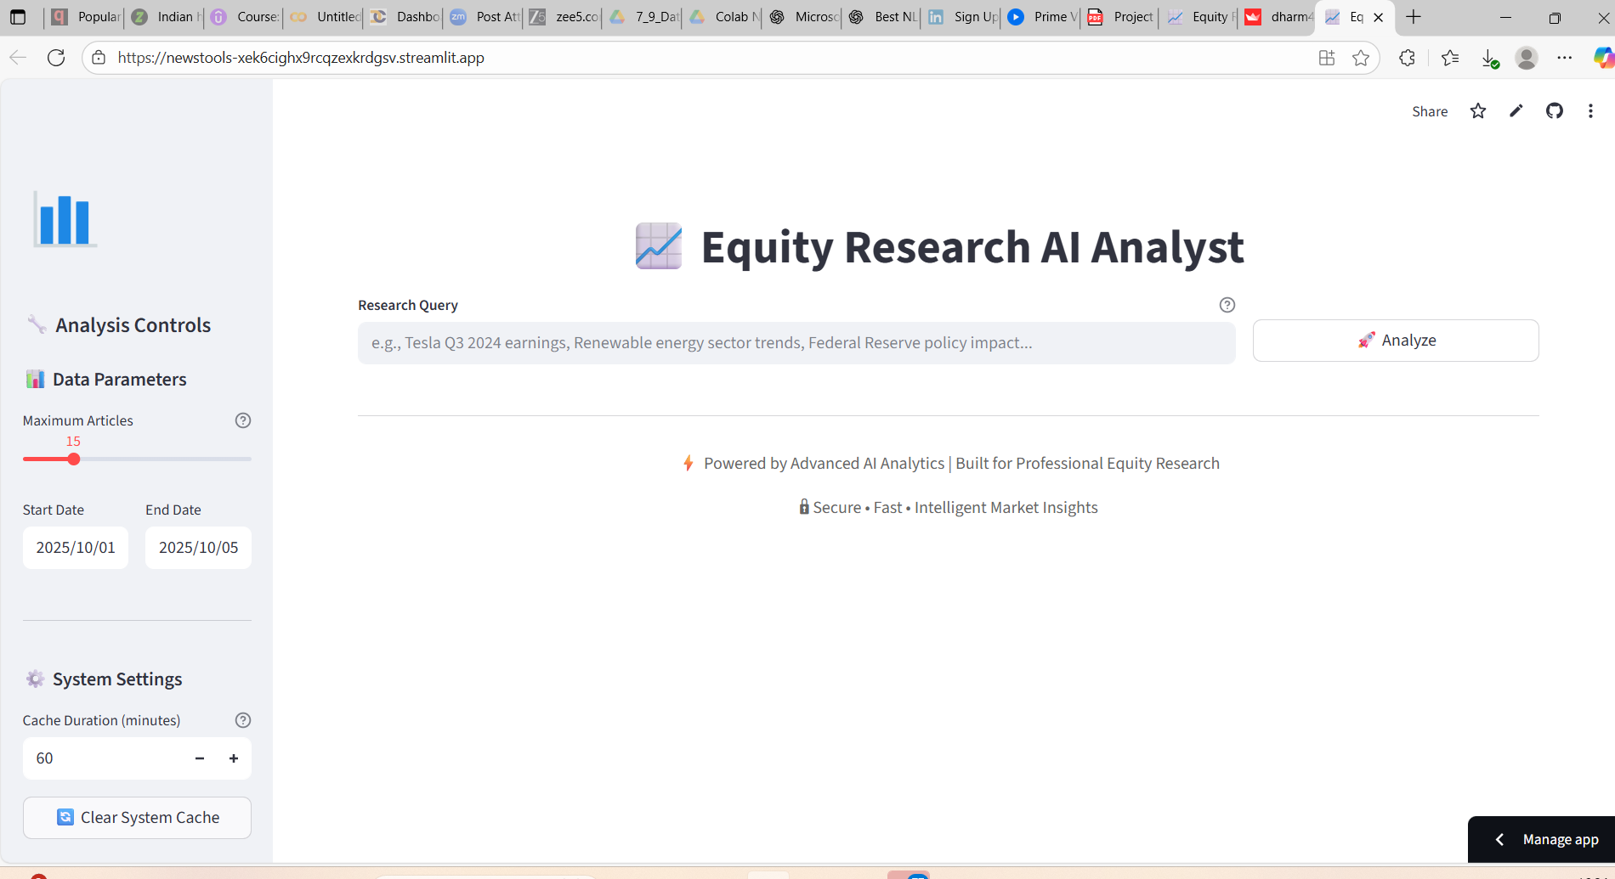

Use this url and check for deployement

[Equity Research AI Analyst · Streamlit](https://newstools-xek6cighx9rcqzexkrdgsv.streamlit.app/)